Compressed Sensing Recovery Algorithms
He Liu
aresmiki@163.com
Southwest Jiaotong University

Sparse optimization algorithm is the key of compressed sensing technology. At present, there are many compressed sensing (CS) recovery algorithms have been proposed. The problem of compressed sensing recovery is actually a minimization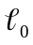problem. Solving norm minimize using combinatorial search is NP-hard, two frequently used sparse recovery algorithms in compressive sensing (CS) are matching pursuit (MP) and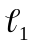norm minimization based algorithm known as basis pursuit (BP). In order to obtain the results of approximateminimization, and to avoid the NP-Hard problem, many sparse recovery algorithms based approximateand 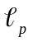norm based minimization problem with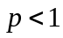 have been proposed. Here I list some of them, and provide the corresponding experimental results. The corresponding Matlab Codes of the following algorithms can be downloaded from my GitHub page, https://github.com/aresmiki.
The signalcould be estimated from noisy measurementby solving the convex minimization problem, called second-order cone program (SOCP), as follows.
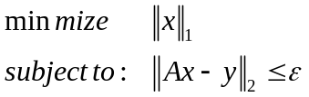
whereis a bound of the amount of noise in the data. For notation convenience, we rephrase theminimization problem for noise free case as
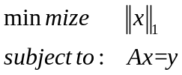
The following recovery algorithms are considered for two optimization models, Please refer to the relevant literature for details.

1. Orthogonal Matching Pursuit (OMP) [1]
Algorithm 1: CS recovery using OMP
Input: The CS observation, and a measurement matrix 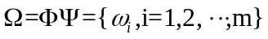 where 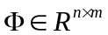 and 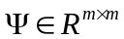.
Initialization: Index 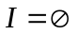, residual 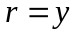, sparse representaton 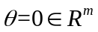.
Iteration:
while(stopping criterion false)
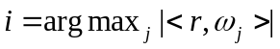;
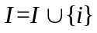;
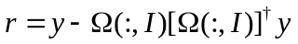
end while
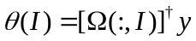
Output: Sparse representation , and the original signal 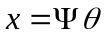.
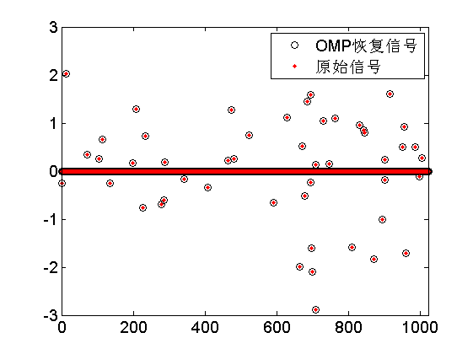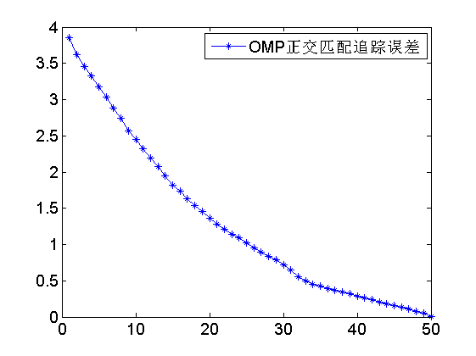
Figure.1. Recovery result by using OMP
2. Compressive Sampling Matching Pursuit (CoSaMP) [2-3]
Algorithm 2: CS recovery using CoSaMP
Input: The CS observation , a measurement matrix where and , and the sparsity of signal based on  is .
Initialization: Residual , sparse representation .
Iteration:
while(stopping criterion false)
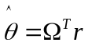;
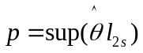;
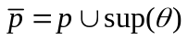;
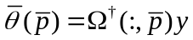;
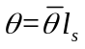;
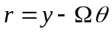;
end while
Output: Sparse representation , and the original signal .
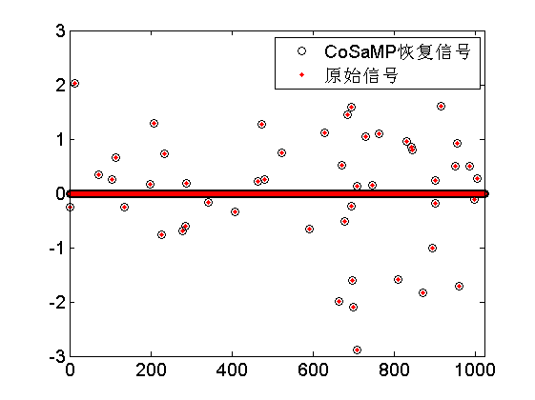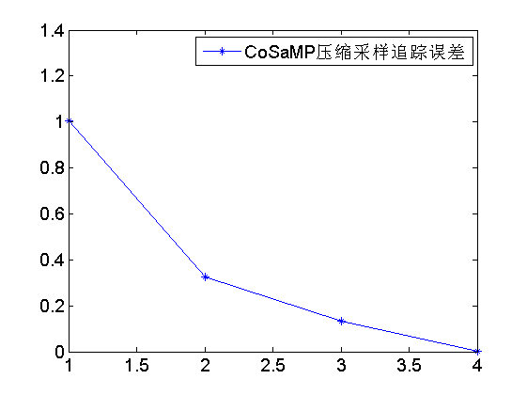
Figure.2. Recovery result by using CoSaMP
3. Fast Iterative Shrinkage-Thresholding Algorithm (FISTA) [4]
Algorithm 3: CS recovery using FISTA
Input: 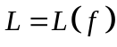---A Lipschitz constant of 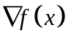.
Step 0: Take 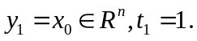
Step: (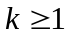) Compute
- 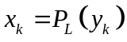by solving the problem:
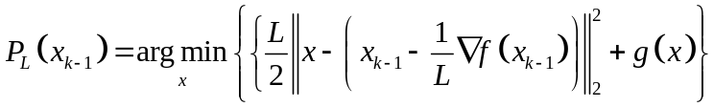
- 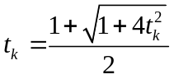
- 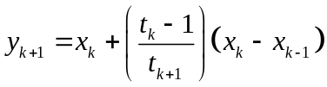
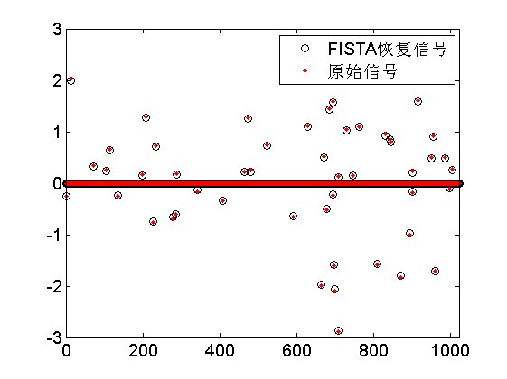
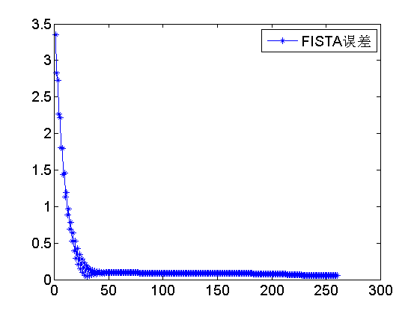
Figure.4. Recovery result by using FISTA
4. Iterative Hard Thresholding algorithms for compressive sensing (IHT) [5-6]
Algorithm 4: CS recovery using IHT
Input: observation, and a measurement matrix.
Initialization: 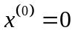
Step: () Compute
- 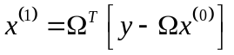
- 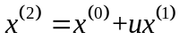
- set all but the largest K elements to zero, where K is the sparsity of the estimate
- 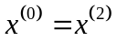

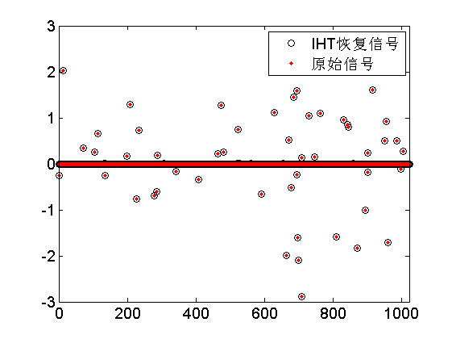
Figure.4. Recovery result by using IHT
5. Iteratively Reweighted Least Square (IRLS) [7]
Algorithm 5: CS recovery using IRLS
Input: The CS observation, and a measurement matrix where and .
Initialization: sparse representation 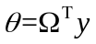,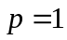,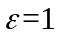.
Iteration:
while (stopping criterion false)
for from 1 to end
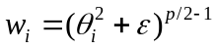;
end
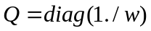;
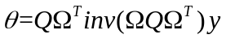;
end whlie
Output: Sparse representation , and original signal .

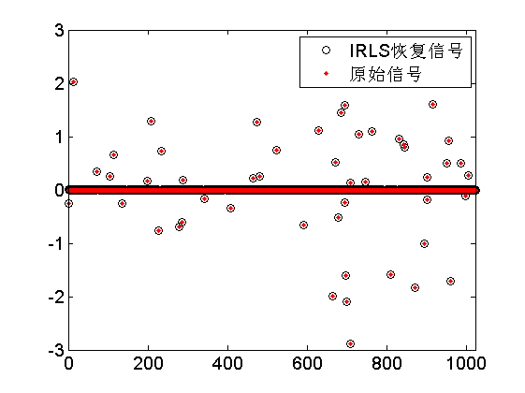
Figure.5. Recovery result by using IRLS
6. Iterative Shrinkage-Thresholding Algorithm (ISTA) [8]
Algorithm 6: CS recovery using ISTA
Input: ---A Lipschitz constant of .
Step 0: Take 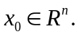
Step: () Compute
- by solving the problem:
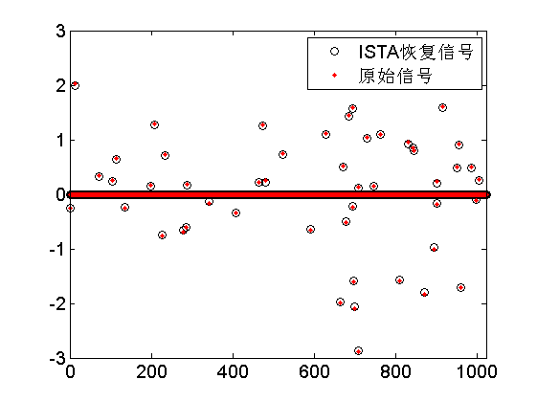
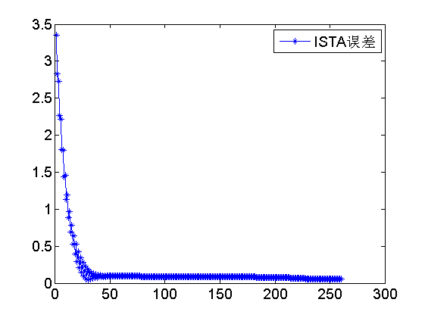
Figure.6. Recovery result by using ISTA
7. Null-Space Reweigthted Approximate l0-Pseudonorm Algorithm (NSRAL0) [9]
Algorithm 7: CS recovery using NSRAL0
Step 1
Input: ,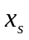,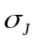,,, and .
Step 2
Set 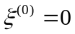,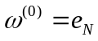,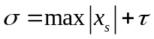, and 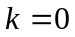.
Step 3
Perform the QR decomposition 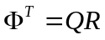and construct 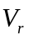 using the last 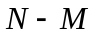 columns of Q.
Step 4
With 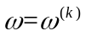 and using 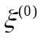 as an initial point, apply the BFGS algorithm to solve the problem in (10), where re-weighting with parameter is applied using 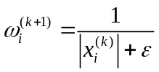 in each iteration. Denote the solution as 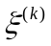.
Step 5
Compute 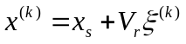 and update weight vector to 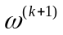 using .
Step 6
If 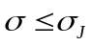. stop and output 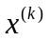 as solution; otherwise, set 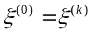,,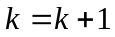, and repeat from Step 4.
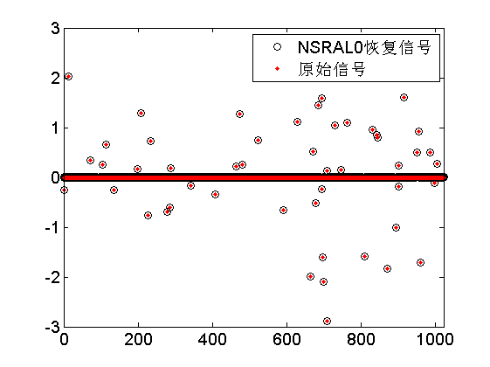
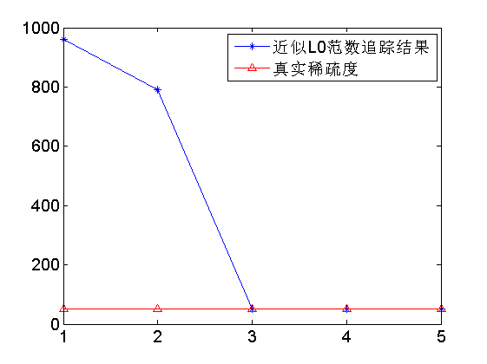
Figure.7. Recovery result by using NSRAL0
8. Reweighted L1 Minimization Algorithm (RL1) [10]
Algorithm 8: CS recovery using RL1
Step 1
Set 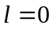 and 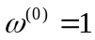 for 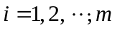.
Step 2
Solve the weighted minimization problem
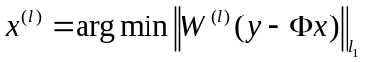.
Step 3
Updata the weights; let 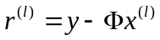 and for each 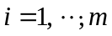,define
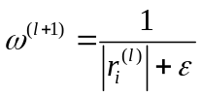.
Step 4
Terminate on convergence or when attains a specified maximum number of iterations 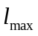.Otherwise, increment and go to Step 2.
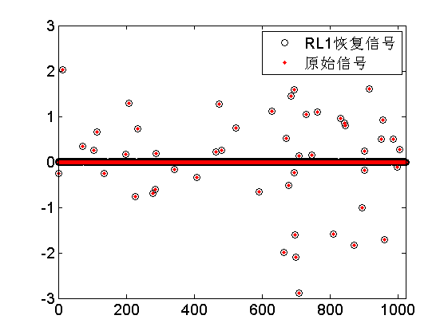
Figure.8. Recovery result by using RL1
9. Robust Smoothed l0-Pseudonorm Algorithm (RSL0) [11]
Algorithm 9: CS recovery using RSL0
Step 1
Let 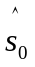 equal to the minimum norm solution of .
Step 2
Choose a suitable decreasing sequence for , 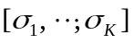.
Step 3
Let 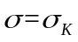.
Maximize (approximately) the function 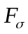 on the feasible set 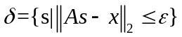;
Initialization: 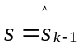
For 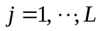
Let 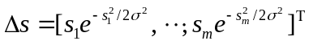.
Let 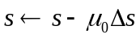.
If 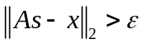 projiect on 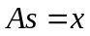 with:
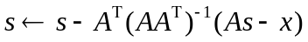.
Set 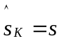.
Step 4
Final answer is 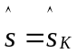.
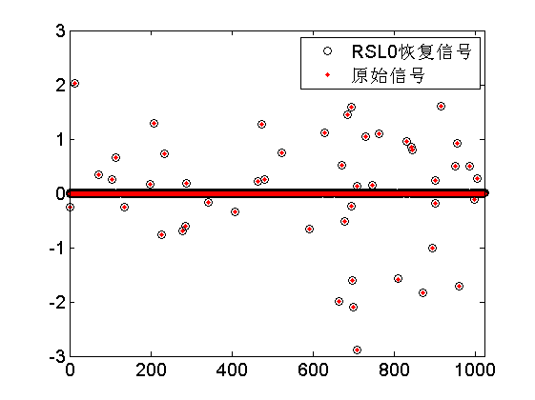
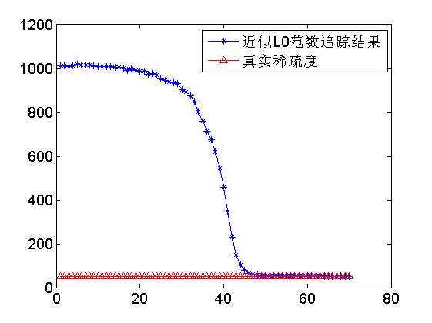
Figure.9. Recovery result by using RSL0
10. L1_SplitBregmanIteration (SBIL1) [12]
Algorithm 10: CS recovery using SBIL1
While 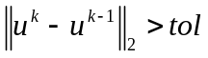
For  to 
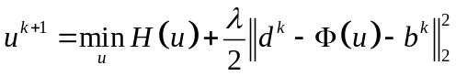, use a wide variety of optimization techniques to solve this problem.
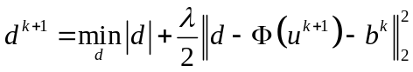, compute the optimal value of using shrinkage operators:
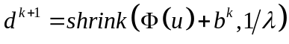, 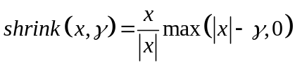
End
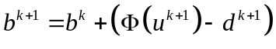
End
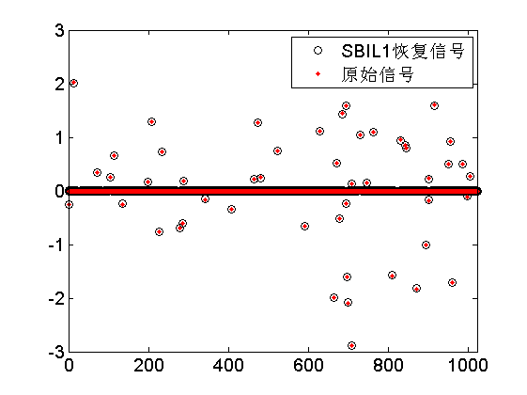
Figure.10. Recovery result by using SBIL1
11. Smoothed l0-Pseudonorm Algorithm (SL0) [13]
Algorithm 11: CS recovery using SL0
Step 1
Set 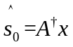. Choose a suitable decreasing sequence for 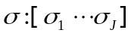.
Step 2
For 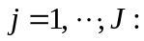
Let 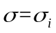.
Maximize 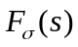 subject to , using iteration of steepest ascent:
Initialization: 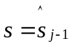.
For 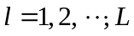
Let 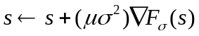.
Project s back onto the feasible set 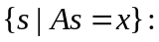
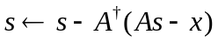.
Set 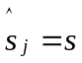.
Step 3
Final answer is 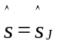.

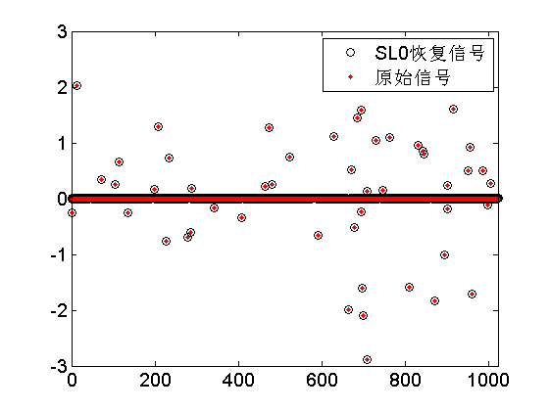
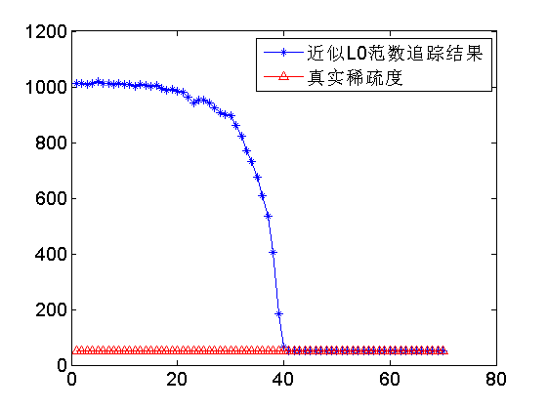
Figure.11. Recovery result by using SL0
12. Minimization of Approximate Lp Pseudonorm Using a Quasi-Newton Algorithm (UALP) [14]
Algorithm 12: CS recovery using UALP
Step 1
Input: 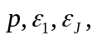 and .
set 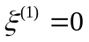.
Step 2
Compute 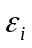 for 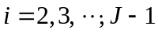 using 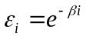 where 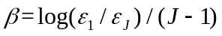.
Step 3
Use 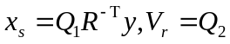 to compute and .
Step 4
Repeat for 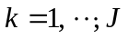
Set 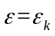 and use 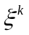 as an initial point. Apply the BFGS algorithm to solve the problem in 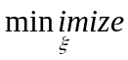 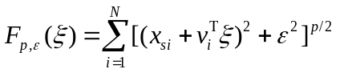.
Denote the solution as 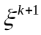.
Step 5
Set 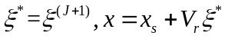, and terminate.
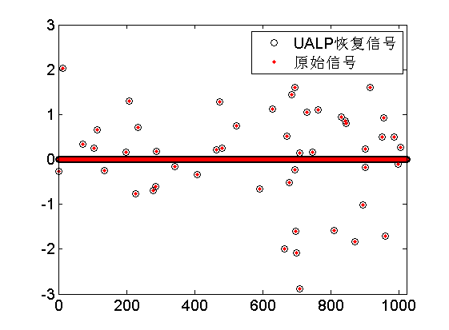
Figure.12. Recovery result by using URLP
Reference
[1] Joel A. Tropp and Anna C. Gilbert Signal Recovery From Random Measurements Via Orthogonal Matching Pursuit，IEEE TRANSACTIONS ON INFORMATION THEORY, VOL. 53, NO. 12.
[2] Needell D，Tropp J A CoSaMP：Iterative signal recovery from incomplete and inaccurate samples[J]．Applied and Computation Harmonic Analysis，2009，26：301-321.
[3] D.Needell, J.A. Tropp．CoSaMP: Iterative signal recoveryfrom incomplete and inaccurate samples[J]. Communications of theACM，2010，53(12)：93-100.
[4] A. Beck and M. Teboulle, “A fast iterative shrinkage-thresholding algorithm for linear inverse problems,” SIAM J. Imaging Sciences, vol. 2, no. 1, pp. 183-202, 2009.
[5] Blumensath T, Davies M E. Iterative hard thresholding for compressed sensing[J]. Applied & Computational Harmonic Analysis, 2009, 27(3):265-274.
[6] Blumensath T, Davies M E. Iterative Thresholding for Sparse Approximations[J]. Journal of Fourier Analysis and Applications, 2008, 14(5):629-654.
[7] Chartrand and W. Yin, “Iteratively Reweighted Algorithms for Compressed Sensing,” 2008.
[8] I. Daubechies, M. Defrise, and C. D. Mol, “An iterative thresholding algorithm for linear inverse problems with a sparsity constraint,” Comm. Pure Appl. Math., vol. 57, pp. 1413-1457, 2004.
[9] J. K. Pant, W.-S. Lu, and A. Antoniou,“Reconstruction of sparse signals by minimizing a re-weighted approximate l0-norm in the null space of the measurement matrix,” IEEE Inter. Midwest Symp. on Circuits-Syst, pp. 430–433, 2010.
[10] Candès E J, Wakin M B, Boyd S P. Enhancing sparsity by reweighted L1 minimization.[J]. Journal of Fourier Analysis & Applications, 2007, 14(5):877-905.
[11] H. Mohimani, M. Babie-Zadeh, and C. Jutten,“A fast approach for overcomplete sparse decomposition based on smoothed l0-norm,” IEEE Trans. Signal Process., vol. 57, no. 1, pp. 289-301, Jan. 2009.
[12] Yin W, Osher S, Goldfarb D, et al.Bregman Iterative Algorithms for L1 Minimization with Applications to Compressed Sensing[J]. Siam Journal on Imaging Sciences, 2008, 1(1):143-168.
[13] H. Mohimani, M. Babie-Zadeh, and C. Jutten,“A fast approach for overcomplete sparse decomposition based on smoothed l0-norm,” IEEE Trans. Signal Process., vol. 57, no. 1, pp. 289-301, Jan. 2009.
[14] Pant J K, Lu W S, Antoniou A.Unconstrained regularized Lp -norm based algorithm for the reconstruction of sparse signals[C] IEEE International Symposium on Circuits and Systems. IEEE, 2011:1740-1743.

